**Team Plan**

***Team Project Group 7: Christian Walker, Nathan Cox***

**Description of System Requirements**

**Use Case**: “Create long-term (18 mo, 2 yr) schedule”

Req: Schedule shall permit for expected entry date.

Req: Schedule shall permit for expected graduation date.

Req: UI shall provide visual representation of the schedule.

Req: Privileged users shall be able to comment on schedules.

**Use Case**: “Update class information”

Req: Application shall allow privileged users to edit course name, times, credits, textbook, description, professor info.

**Use Case**: “Add course”

Req: Application shall allow users to search for a course.

Req: Queries shall show course information.

Req: Searched courses can be added to a schedule.

Req: Courses can be added for specific semesters.

Req: Application shall allow privileged users to create a course.

**Use Case**: “Delete course”

Req: Application shall allow user to delete a course from their schedule.

Req: The application shall confirm the deletion request with user.

Req: Application shall allow privileged users to remove a course from the system.

**Use Case**: “Show course info (all, by semester)”

Req: Course info shall display required textbook.

Req: Course info shall display course description.

Req: Course info shall display Professor information.

Req: Course info shall display Credits/Hours.

Req: Course info shall display semester availability.

**Use Case**: “Degree evaluation”

Req: Application shall provide feedback on graduation eligibility.

Req: Application shall track completed credits.

**Use Case**: “List remaining requirements”

Req: Application shall display remaining course requirements.

**Use Case**: “List/evaluate pre-requisites”

Req: Scheduled courses shall highlight courses which have prerequisites.

Req: Scheduled courses with prerequisites shall link to required courses.

Req: Application shall show status of completed/scheduled prerequisites.

**Other Requirements**:

Req: Application shall sign out existing user after 5 minutes of inactivity (+/- 10ms)

Req: Application shall require username and password to access account information.

Req: Upon Closure of application, the user shall be prompted by a confirmation dialogue box.

Req: Application shall allow for the ability to draft a schedule.

Req: Application shall allow for the ability to save a drafted schedule.

Req: Privileged users shall have access to viewing other users’ perspectives.

Req: Application shall allow user to change or update their password.

Req: Application shall allow submission of schedules for review.

Req: Application shall be mobile friendly.

**PERT Chart - duration in days**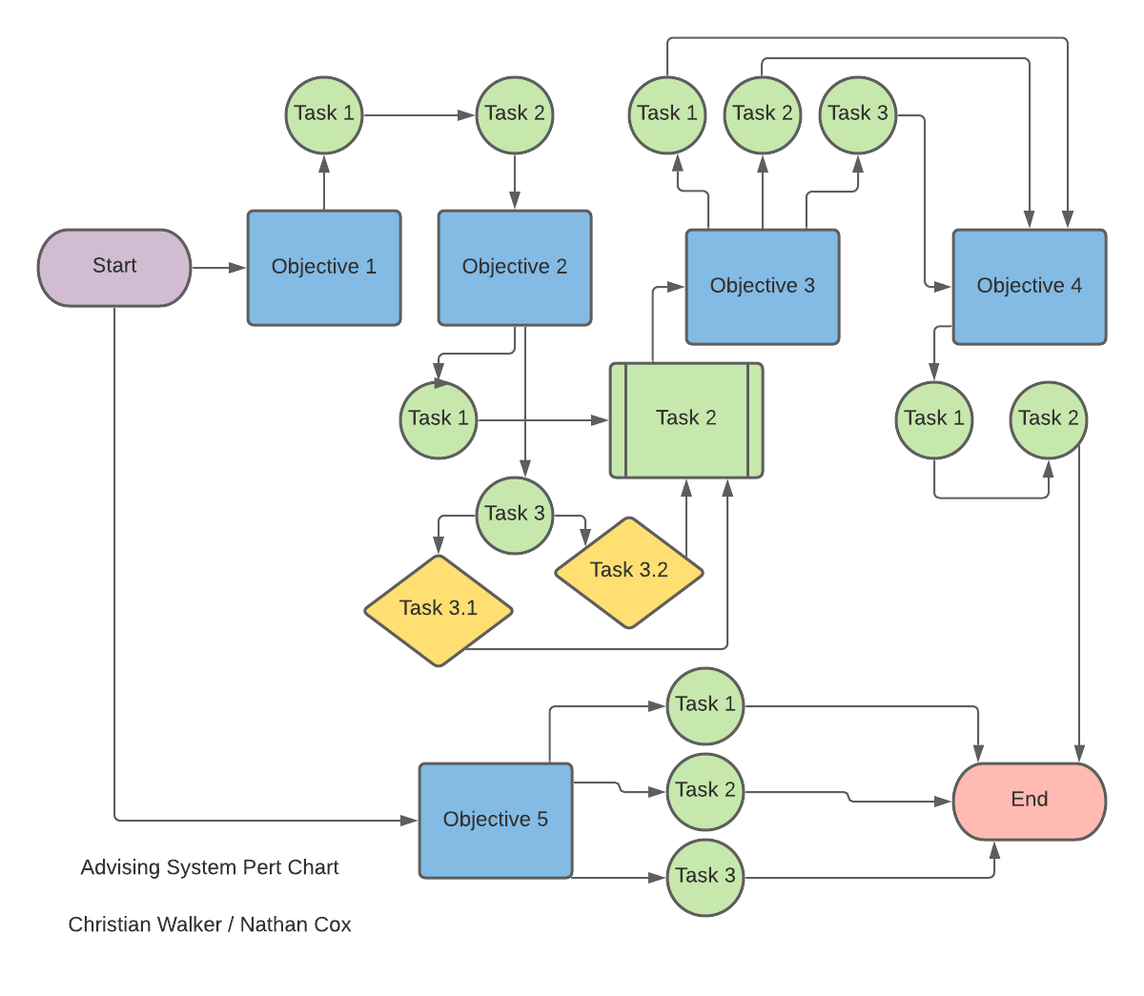

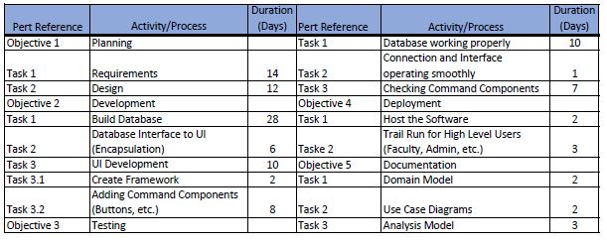

**Gantt Chart**

